Our vision for Music
Our vision for our music department is to allow every KS3 student to partake in new activities and experiences. Every lesson is shaped to contribute to a bigger project, whether that be a performance, creation of a composition, or knowledge of a new genre of music. For students, music allows them to work with another member building on teamworking skills. There is also problem solving, resilience, when learning a new instrument. There are also opportunities to listen to a new type of music, or music from their background and culture. We also create music using technology, which is a huge part of society. This can help us becoming better technicians for future careers and projects, musically and overall.
Extracurricular is also at the heart of what the music department is and continuing to make bigger. This allows students extra time on an instrument they may have enjoyed in lesson or lean a new one. It’s a chance to make new friends, be a part of a bigger project or performance. There are opportunities to display work, in our Winter Showcase, and Summer Showcase, also known as Copachella. We want as many children as possible to enjoy their experience of music, and to continue the passion and love for the subject, studying GCSE Music.
Over the years, we have also engaged with the wider community, getting specialists in and professionals to support learning, again exposing that music is not just listening to a streaming service, that there are clubs, places, companies you can join in with to create and perform music.
Our ultimate goal for your student is to enjoy and appreciate all kinds of music from different historical contexts and cultures.
Detail | Information
Academic year that this summary covers | 2024-25
Date this summary was published
Date this summary will be reviewed | 3rd September 2025
Name of the school music lead | Miss C Plaice
Name of school leadership team member with responsibility for music | Mrs P Coggan
Name of local music hub | Peterborough Music Hub

Part A: Curriculum
KS3
All students in KS3 have an hour of music every week. These lessons are either with a subject specialist, or a person who has worked in the music industry. Every year group learn about 3 or 4 different topics and genres, learning about the three key strands of music: appraisal (listening, performance and composition (creating music). The following shows the topics your child will be learning in each year group:
Year 7 | Year 8 | Year 9
African Drumming | Film Soundtracks | Video Game Soundtracks
Keyboard Skills | Blues | Battle of the Bands
Theme and Variations | Rap | Around the World…
Samba | Rock ‘n’ Roll (whole class instrumental) | Around the World…

Our curriculum is informed by the Model Music Curriculum, filtered through these different topics. Students will get the opportunity to play on a variety of instruments, with some repeated throughout the years. These range from keyboard to ukulele as well as world instruments such as djembe or tambourim. At the end of Year 8, students will take part in a whole class instrumental format, learning to play a woodwind or brass instrument within the classroom.
Graded exams
The school are currently in the process of looking to offer students the opportunity to take a graded exam through ABRSM or Trinity. This will be communicated to parents at a later date.
This will happen during peripatetic lessons, which are bring offered to Year 8 onwards currently, with the addition of Year 7 later in the academic year.

KS4
Students that choose to take GCSE Music will be undertaking OCR GCSE (9-1) in Music. There is an information booklet given to students who are interested at GCE options evening, however, if you would like to receive one, please get in contact with the school or the lead teacher of music (Miss C Plaice). The three components of the course look like this:
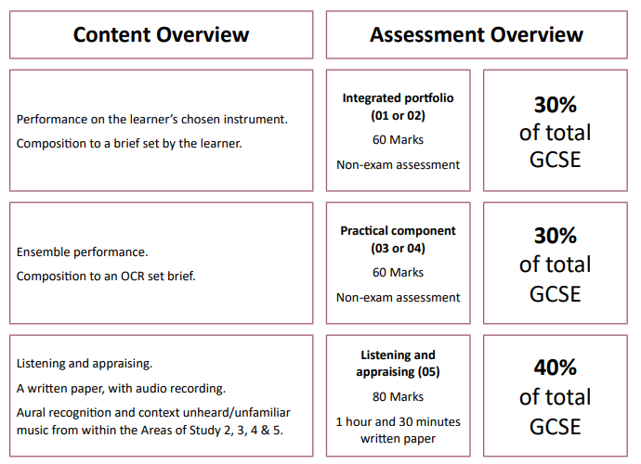

Part B: Extra-curricular music
Music tuition (peripatetic lessons) is currently being offered to students in Year 8 and above. The instruments being offered are drums, electric/acoustic guitar and bass guitar. We are working on getting another teacher to come in to teach other instruments. These lessons are usually 1-1, but sometimes in pairs due to numbers.
There are a variety of clubs being offered both at lunch times and afterschool for students to join. These are for all students, not just those who have peripatetic, although it is encouraged that students who do receive those lessons, join extracurricular clubs. The extracurricular timetable will be available on the website.
We also have a strong relationship with the music hub, Peterborough Music Hub, where they have loaned us equipment and workshops to get involved in. They also offer an extracurricular activity on Saturday, called PCYM (Peterborough Centre for Young Musicians). The link for that is here: https://pcym.org.uk/
Part C: Musical Experiences
CoPA currently have two different performance opportunities for children to get involved in. The first is the Winter Showcase, usually for all performers and ensembles. Second, during the final term is Copachella, based on the namesake Coachella, where a festival brings different groups together within the creative arts.
We have also had the pleasure of inviting in different workshops, namely a local rapper who supported students in creating their own lyrics. We get involved with the Peterborough Music Hub performances as well.
This year we are looking to go out on trips and get more external agencies and workshops involved with our school.
Part D: In the future
As a department, we would like to continue to great work happening in the lessons. Our aim is to expand our extracurricular offer, as well as our musical experiences.
In terms of curriculum, we would like to celebrate those who aim high and challenge themselves to take on music grades, and have students go on to sixth form studying A-Level or BTEC/RSL music courses.

